RESIDENTIAL PROGRAMME PLANNING:
COURSE LEADER INFORMATION

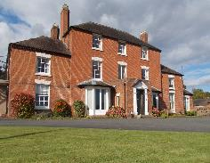
10 Key Outcomes of High Quality Outdoor Learning (OEAP)
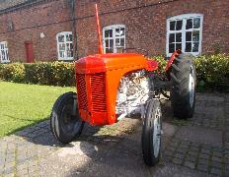
g
- Personal qualities
- Health and wellbeing
- Activity skills
- Increased motivation
- Social and emotional awareness
- Environmental awareness
- Confidence and character
- Broadened horizons
- Skills for life
- Enjoyment

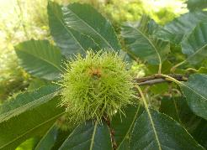
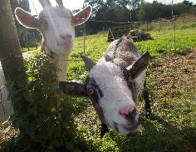

All these are important outcomes and are likely to be met to some extent during your outdoor residential at Edgmond Hall. Please consider which two outcomes are the most important for your current group coming away on residential.
To try to maximise the value of the residential for both children and staff, please read the following information and consider the points outlined before Edgmond Hall staff discuss your programme with you. If you have organised programmes before, please remember that each group is unique with their own specific needs, so looking at this process each year should prove valuable.
Things for you to consider when planning your residential - the following points have been recommended based on research from ‘Learning Away – Brilliant Residentials’

- Fully integrated with the school curriculum and ethos
- Designed and led by teachers and, where appropriate, students
- Inclusive and affordable for all students
- Deliberately and collaboratively planned to meet students’ specific learning needs, and to embed and reinforce learning back in school
- Part of a progressive programme of experiences
- Designed to include a wide range of new and memorable experiences
- Designed to allow space for students to develop collaborative relationships with both peers and staff
- Evaluated rigorously
- Supported by senior leadership and school governors.

Purpose - Which of these is the priority for your residential?

- Personal and social development.
- New learning to cover curriculum content.
- Curriculum links relating to a theme or topic.
- Outdoor experiences in a new or different environment.

Things to consider when planning the content of your programme:
- Outcomes for each session
- The range and type of activities that will suit this group...
- Age appropriate?
- Physical or less physical?
- Creative?
- Onsite or offsite?
- In depth or short and snappy, taster, sustained?
- The time of year
- Group size and dividing the group up for activities
- Any additional needs in the group
- How best to use the evening sessions?
- How you want children to reflect on / record experiences
- Your staffing needs / ratios for this group
The following things will be discussed further as we plan the course:
- The main outcomes you hope to achieve by coming away on residential to Edgmond Hall (from 10 HQ outcomes)
- The purpose of the residential and what aspect(s) you want to focus on (see above) e.g. What specific aspects of your PSHE / SMSC curriculum do you you’re your programme to incorporate? What curriculum subject areas or topics do you want to cover? Do you want a themed course? (Pirates, Harry Potter, Romans, Egyptians, Halloween)
- The focus and learning / experiential outcomes for each of the activity session.
- Any specific school initiatives that can be supported during the residential.
- How Edgmond Hall may be able to support work on Wellbeing and / or exploring greater understanding of feelings and emotions.
- Logistics –expected numbers, any students with additional needs, overview of a typical day, praise or reward systems, gift shop or gift bags, feelings diary /passports, timeline for organisation / information, discussing outcomes and logistics of the trip with the other staff attending the trip, staff medical forms.

www.learningaway.org.uk

