COVID 19 OPERATING PROCEDURES

We look forward to meeting your group; we’re sure that the visit will be both worthwhile and fun. We also want it to be as safe as possible for pupils, visiting staff, and centre staff, so along with our usual activity risk assessments, we have implemented measures to reduce the risk from Covid-19. Please note that these may differ from those in school. I should be grateful if all group leaders would familiarise themselves with the measures below, share them with other visiting staff and pupils in advance of the visit, and help us to implement them throughout the visit. Should you have any questions or concerns, please contact the centre that you are booked at.

Before the visit
Children or adults with any symptoms, or who have tested positive prior to the visit, should not attend – as would be the case with most illnesses.

During the visit
In the event of showing symptoms of Covid whilst at a centre, arrangements should be made for pupils (and adults) to be distanced from other people and returned home as soon as possible. This is in line with the latest government guidance detailed below.

Government guidance – Spring 2022
From 1 April, updated guidance will advise people with symptoms of a respiratory infection, including COVID-19, and a high temperature or who feel unwell, to try to stay at home and avoid contact with other people until they feel well enough to resume normal activities and they no longer have a high temperature. Until 1 April individuals should continue to follow the current guidance.

From 1 April, anyone with a positive COVID-19 test result will be advised to try to stay at home and avoid contact with other people for 5 days, which is when they are most infectious.

Children and young people who are unwell and have a high temperature should stay at home and avoid contact with other people, where they can. They can go back to school, college or childcare when they no longer have a high temperature, and they are well enough to attend.

Please do contact the centre if you have any questions or concerns regarding the above.

Many thanks,
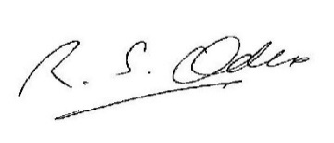

Richard Oakes, SRES Manager

